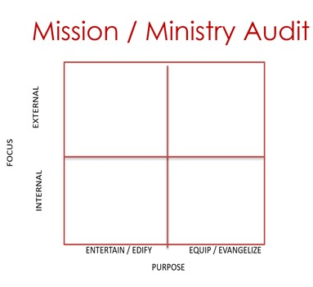

Sample Ministry 1 Sample Ministry 2

Sample Ministry 3 Sample Ministry 4

